What is Infrastructure as Code (IaC)?
Infrastructure as Code (IaC) means you define your infrastructure using code, instead of clicking around in a web console.
So instead of:
- manually creating servers
- clicking buttons to make networks
- hoping you remember what you changed last week 😬
You write config files that describe:
- what infrastructure you want
- how it should be configured
Then a tool creates it exactly that way, every time.
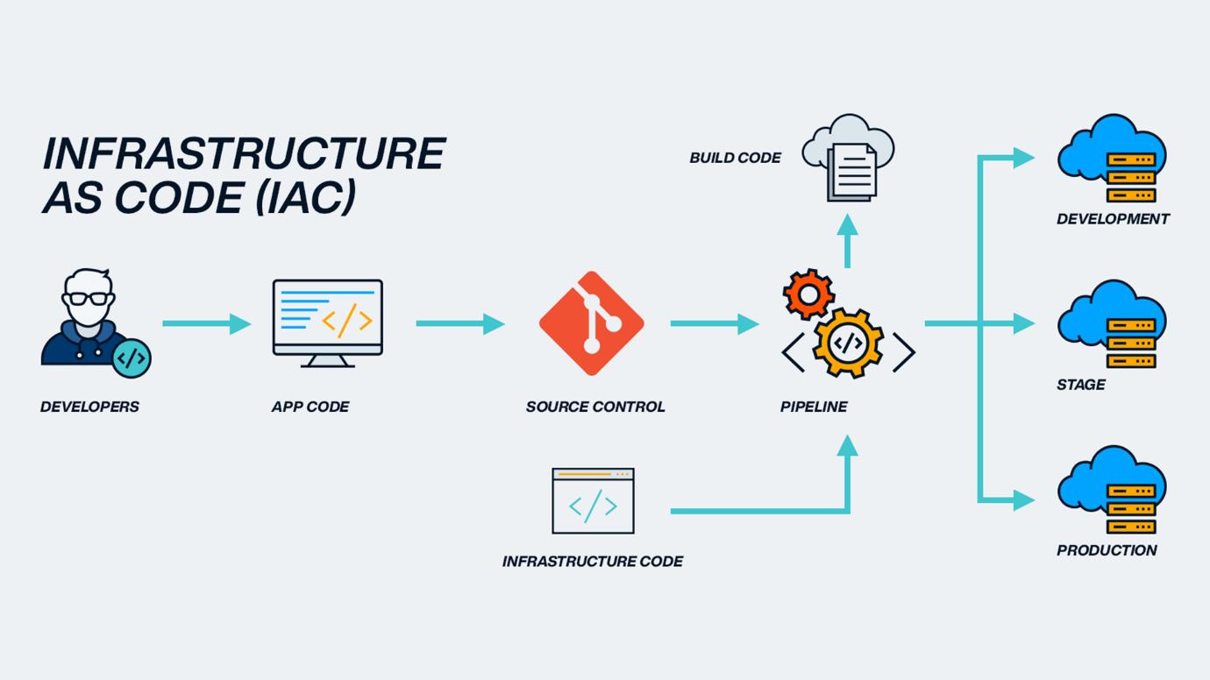

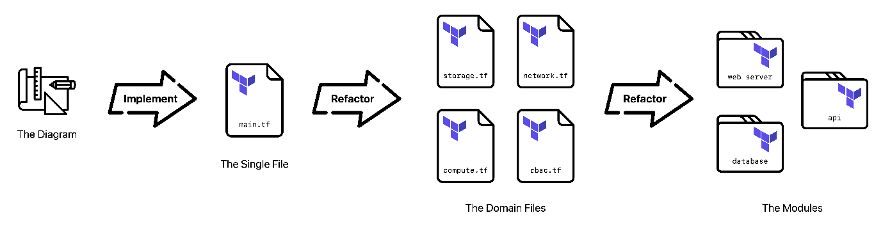
IaC gives you:
- ✅ Consistency – same setup every time
- ✅ Automation – no manual clicking
- ✅ Version control – infra changes in Git
- ✅ Repeatability – dev, staging, prod all match
- ✅ Disaster recovery – rebuild infra from code

What is Terraform?
Terraform is one of the most popular IaC tools.
It lets you:
- define infrastructure in a language called HCL
- create infrastructure across many providers
- manage infrastructure lifecycle (create, update, delete)
Terraform is developed by HashiCorp.

What Terraform actually does
Terraform follows a simple loop:
- Write code describing infrastructure
- Plan what will change
- Apply those changes
- Track everything in state
Example:
resource "aws_s3_bucket" "example" {
bucket = "my-app-bucket"
}
Terraform reads this and says:
“Got it. I’ll create an S3 bucket with this name.”

Key Terraform concepts (super important)
Concept | What it means
IaC | Managing infrastructure with code
Terraform | Tool that implements IaC
Providers | APIs Terraform talks to (AWS, Azure, GitHub, etc.)
Resources | The actual things you create
State | Terraform’s record of what exists
Plan | Preview of changes
Apply | Makes the changes real

Terraform vs other IaC tools
Tool | Scope
Terraform | Multi-cloud & SaaS
CloudFormation | AWS-only
ARM/Bicep | Azure-only
Pulumi | IaC using real programming languages
Terraform’s superpower: one tool, many platforms.

Why companies love Terraform
Terraform lets teams:
- spin up environments fast
- avoid configuration drift
- review infra changes like code
- scale infrastructure safely
- automate CI/CD pipelines
That’s why it’s everywhere in DevOps.

One-sentence summary
- IaC = managing infrastructure using code
- Terraform = a tool that makes IaC work across many platforms

Terraform variables are a way to make your infrastructure code flexible, reusable, and configurable instead of hard-coding values everywhere.
Think of them like parameters you pass into your Terraform setup.

What problem do variables solve?
Without variables, you’d write stuff like:
instance_type = "t3.micro"
region = "us-east-1"
That’s fine… until you want:
- a different region
- a bigger instance
- separate dev / staging / prod environments
Variables let you change values without changing the code.

Basic example
1. Declare a variable
variable "instance_type" {
description = "EC2 instance type"
type = string
default = "t3.micro"
}
2. Use the variable
resource "aws_instance" "example" {
instance_type = var.instance_type
}
var.instance_type pulls in the value.

Ways to set variable values (very important)
Terraform checks these in order:
- Command line
terraform apply -var="instance_type=t3.large"
- .tfvars files
instance_type = "t3.small"
Then:
terraform apply -var-file="terraform.tfvars"
- Environment variables
export TF_VAR_instance_type=t3.medium
- Default value (used only if nothing else is set)

Common variable types
# String
variable "region" {
type = string
}

# Number
variable "instance_count" {
type = number
}

# Boolean
variable "enable_monitoring" {
type = bool
}

# List
variable "subnets" {
type = list(string)
}

# Map
variable "tags" {
type = map(string)
}

No default = required variable
variable "db_password" {
type = string
sensitive = true
}
Terraform will prompt you if you don’t provide it.

Sensitive variables
Mark secrets so they don’t show in logs:
variable "db_password" {
type = string
sensitive = true
}
Terraform still uses it — it just hides it from output.

Why variables matter in real projects
Variables help you:
- reuse the same code across environments
- avoid copy-paste Terraform files
- keep secrets out of source control
- make modules actually usable

Terraform providers are what let Terraform talk to the outside world.
If variables are the inputs, providers are the connectors.

What is a provider?
A provider is a plugin that knows how to:
- authenticate with an API
- create, read, update, and delete resources
- translate Terraform code into real infrastructure changes
Without providers, Terraform wouldn’t know how to create anything.

Simple mental model
- Terraform core → plans & state
- Provider → API logic
- Cloud/service → AWS, Azure, GitHub, Kubernetes, etc.
Terraform core says what to do.
Providers know how to do it.

Example: AWS provider
provider "aws" {
region = "us-east-1"
}
Now Terraform can create AWS resources.
resource "aws_instance" "example" {
instance_type = "t3.micro"
ami = "ami-0abcdef123"
}
aws_instance comes from the AWS provider.

Where providers come from
Most providers are downloaded automatically from:
Terraform Registry (registry.terraform.io)
Examples:
- AWS
- AzureRM
- Google
- Kubernetes
- GitHub
- Docker
Terraform downloads them during:
terraform init

Required providers block (best practice)
terraform {
required_providers {
aws = {
source = "hashicorp/aws"
version = "~> 5.0"
}
}
}
This:
- locks the provider source
- controls version upgrades
- makes builds reproducible

Provider configuration vs resources
Provider config = credentials & region
provider "aws" {
region = "us-west-2"
}
Resources = actual infrastructure
resource "aws_s3_bucket" "bucket" {
bucket = "my-app-bucket"
}

Multiple providers (or multiple configs)
Different regions
provider "aws" {
region = "us-east-1"
}

provider "aws" {
alias = "west"
region = "us-west-2"
}
Use it like:
resource "aws_s3_bucket" "west_bucket" {
provider = aws.west
bucket = "my-west-bucket"
}

Authentication
Providers handle auth, usually via:
- environment variables
- config files (e.g. ~/.aws/credentials)
- explicit provider blocks (not recommended for secrets)
Terraform itself never stores your passwords — the provider handles that.

Providers vs variables (quick contrast)
Concept | Purpose
Variables | Input values
Providers | API connectors
Resources | Things you create
State | What exists

Why providers matter
Providers let Terraform manage:
- cloud infrastructure
- SaaS tools
- databases
- DNS
- monitoring
- CI/CD platforms
If there’s an API, there’s probably a provider.

What are modules in Terraform?
A Terraform module is a reusable, self-contained package of Terraform code.
Think of a module like a function:
- it takes inputs (variables)
- creates resources
- returns outputs
- can be reused over and over
If Terraform files are LEGO bricks, modules are prebuilt LEGO sets 🧱➡️🏗️

Why modules exist
Without modules:
- lots of copy-paste
- inconsistent setups
- painful changes across environments
With modules:
- write infra once
- reuse it everywhere
- enforce standards
- reduce mistakes

The simplest kind of module (local module)
Folder structure:
modules/
ec2/
main.tf
variables.tf
outputs.tf
main.tf
resource "aws_instance" "this" {
ami = var.ami
instance_type = var.instance_type
}
variables.tf
variable "ami" {
type = string
}

variable "instance_type" {
type = string
}
outputs.tf
output "instance_id" {
value = aws_instance.this.id
}

Using a module
In your root Terraform config:
module "web_server" {
source = "./modules/ec2"

ami = "ami-0abcdef123"
instance_type = "t3.micro"
}
Boom — you just reused infrastructure.

Inputs and outputs (the contract)
Modules communicate using:
- variables → inputs
- outputs → results
output "web_instance_id" {
value = module.web_server.instance_id
}
This makes modules:
- predictable
- safe to reuse
- easy to compose

Types of modules
1. Root module
The Terraform code you run:
terraform apply
This is always a module — the root module.

2. Local modules
Stored in your repo:
source = "./modules/vpc"

3. Remote modules
Pulled from:
- Terraform Registry
- GitHub
- S3, etc.
Example:
module "vpc" {
source = "terraform-aws-modules/vpc/aws"
version = "~> 5.0"
}

Public module registry
Terraform has a massive ecosystem of prebuilt modules on the registry:
- VPCs
- EKS clusters
- RDS
- Load balancers
You don’t need to reinvent everything — just configure.

Modules + providers
Modules don’t create providers — they inherit them.
You configure providers in the root module:
provider "aws" {
region = "us-east-1"
}
Then all child modules use it automatically.
(You can pass providers explicitly, but that’s advanced territory.)

Best practices for modules
- One logical responsibility per module
- Keep modules small and composable
- Always use variables & outputs
- Version your modules
- Don’t hardcode regions, names, or sizes

Modules vs variables (quick comparison)
Concept | Purpose
Variables | Parameterize values
Modules | Reuse infrastructure
Resources | Create things
Providers | Talk to APIs

One-sentence summary
Terraform modules let you package and reuse infrastructure like building blocks instead of copy-pasting code.

What are provisioners in Terraform?
Provisioners let Terraform run scripts or commands on:
- the local machine running Terraform, or
- the remote resource after it’s created
They’re typically used for bootstrapping or configuration tasks.

Basic example
Remote-exec (run commands on a server)
resource "aws_instance" "example" {
ami = "ami-0abcdef123"
instance_type = "t3.micro"

provisioner "remote-exec" {
inline = [
"sudo apt update",
"sudo apt install -y nginx"
]
}
}
Terraform creates the instance, then SSHs into it and runs commands.

Types of provisioners
1. remote-exec
Runs commands on the resource
provisioner "remote-exec" {
script = "setup.sh"
}

2. local-exec
Runs commands on your local machine
provisioner "local-exec" {
command = "echo Instance created!"
}
Common uses:
- notifications
- calling scripts
- triggering external tools

3. file
Copies files to a remote machine
provisioner "file" {
source = "app.conf"
destination = "/etc/app.conf"
}

How provisioners actually work
Provisioners run:
- after resource creation
- only during apply
- not during plan
If a provisioner fails:
- Terraform marks the resource as tainted
- the apply may fail or retry
This can get messy fast.

Why provisioners are discouraged ⚠️
Terraform’s own docs say:
Use provisioners as a last resort
Reasons:
- ❌ Not idempotent (reruns can break things)
- ❌ Hard to debug
- ❌ Can fail due to timing/network issues
- ❌ Mix infra creation with config management
- ❌ Break Terraform’s declarative model
Provisioners turn Terraform into a configuration manager, which it’s not great at.

What to use instead (preferred options)
✅ Cloud-init / user_data
resource "aws_instance" "example" {
user_data = file("cloud-init.yaml")
}
Runs at boot, reliably.

✅ Configuration management tools
- Ansible
- Chef
- Puppet
- Salt
Terraform creates infra, these tools configure it.

✅ Managed services
Instead of provisioning servers:
- use RDS instead of installing MySQL
- use EKS instead of installing Kubernetes
- use SaaS when possible
Less to manage = fewer headaches.

When provisioners are acceptable
Provisioners make sense when:
- there’s no API alternative
- you’re doing one-time glue work
- legacy systems force your hand
Examples:
- registering a server with an old system
- running a one-off script after creation
- calling a custom internal tool
Even then — be careful.

Provisioners vs everything else
Tool | Responsibility
Terraform | Infrastructure lifecycle
Provisioners | Last-resort scripting
Cloud-init | Bootstrapping
Ansible | Configuration management

What is a Terraform backend?
A backend defines where Terraform stores its state file and how it’s accessed.
Remember:
Terraform uses a state file to track what infrastructure exists.
By default, that file is local:
terraform.tfstate
That’s fine for learning — terrible for teams.

Why backends matter
Backends let you:
- store state remotely
- share state across a team
- lock state (avoid two people applying at once)
- secure state (encryption, access control)

Common backend types
Backend | Use case
local | Default, single-user
S3 | Most common (with DynamoDB locking)
AzureRM | Azure storage
GCS | Google Cloud
Terraform Cloud | Managed backend

Example: S3 backend
terraform {
backend "s3" {
bucket = "my-terraform-states"
key = "network/terraform.tfstate"
region = "us-east-1"
dynamodb_table = "terraform-locks"
encrypt = true
}
}
Now:
- state lives in S3
- DynamoDB handles locking
- multiple people can safely run Terraform
Backends are initialized with:
terraform init

Important backend rules ⚠️
- Backend config does not support variables
- Changing backend = re-running terraform init
- Only one backend per Terraform configuration

What are Terraform workspaces?
Workspaces let you use the same Terraform code with multiple state files.
Think:
- same code
- different environments
- separate states

Default workspace
Every Terraform project starts with:
default
You can list workspaces:
terraform workspace list
Create a new one:
terraform workspace new dev
terraform workspace new prod
Switch:
terraform workspace select dev
Each workspace = separate state

How workspaces affect state
Terraform automatically changes the state path.
Example with S3 backend:
s3://bucket/key/default.tfstate
s3://bucket/key/dev.tfstate
s3://bucket/key/prod.tfstate
Same backend, different state files.

Using workspaces in code
You can branch logic based on workspace:
locals {
instance_type = terraform.workspace == "prod"
? "t3.large"
: "t3.micro"
}
Or:
resource "aws_instance" "app" {
count = terraform.workspace == "prod" ? 3 : 1
}

Workspaces vs separate folders
This is where opinions get spicy 🌶️
Workspaces are good for:
- simple dev/test environments
- experimentation
- non-critical isolation
Workspaces are not great for:
- complex prod environments
- different regions/accounts
- very different configs
- strict isolation requirements
Many teams prefer:
envs/
dev/
staging/
prod/
Each with its own backend config.

Backend vs Workspace (clear contrast)
Concept | What it controls
Backend | Where state is stored
Workspace | Which state file is active
Backend + Workspace | Remote + multi-env
Workspace alone | Local multi-env

How they work together
- Backend = storage location (S3, Terraform Cloud, etc.)
- Workspace = which state file inside that backend
Backend is the warehouse
Workspace is the labeled shelf

One-sentence summary
- Backends define where and how Terraform state is stored
- Workspaces let you use multiple state files with the same Terraform code

What is Terraform import?
Terraform import lets you:
- take a resource that already exists (created manually or by another tool)
- map it into Terraform state
- manage it going forward with Terraform
Important: import does NOT create resources
It only updates Terraform’s state.

Why imports are needed
You use imports when:
- infra already exists before Terraform
- migrating from click-ops to IaC
- adopting Terraform gradually
- taking over legacy environments
Without import, Terraform would try to recreate everything.

Basic import flow (super important)
1. Write the resource block
Terraform needs a place to put the imported resource.
resource "aws_s3_bucket" "logs" {
bucket = "my-existing-bucket"
}
This must exist before import.

2. Run the import command
terraform import aws_s3_bucket.logs my-existing-bucket
Terraform now:
- finds the real bucket
- maps it to aws_s3_bucket.logs
- stores it in state

3. Fix the configuration
Run:
terraform plan
Terraform will say:
“Hey, the real resource doesn’t exactly match your code.”
You then:
- update the .tf files
- repeat until plan shows no changes
This step is critical.

Import ≠ full configuration
Terraform does not generate your Terraform code for you.
After import:
- state knows the resource
- code may be incomplete or wrong
You must manually align code with reality.

Import blocks (Terraform 1.5+)
Modern Terraform supports import blocks, which is 🔥.
import {
to = aws_s3_bucket.logs
id = "my-existing-bucket"
}
Then:
terraform apply
Terraform imports during apply — no CLI import command needed.
This is:
- versionable
- reviewable
- CI-friendly

What can be imported?
Almost anything that:
- already exists
- has a stable ID
- is supported by the provider
Examples:
- EC2 instances
- VPCs
- S3 buckets
- IAM roles
- GitHub repos
- Kubernetes resources
Each provider documents the import ID format.

Common gotchas ⚠️
- Wrong import ID → import fails
- Missing attributes → Terraform wants to change things
- Some resources are partially importable
- Renaming a resource = state move, not re-import

Import vs state mv vs state rm
Command | Purpose
terraform import | Bring existing infra into state
terraform state mv | Rename or refactor resources
terraform state rm | Stop managing a resource
Different tools, very different consequences.

When NOT to use import
Avoid imports when:
- you can safely recreate infra
- the resource is ephemeral
- config drift is extreme and risky
Sometimes rebuilding clean is easier.

Real-world use case
Common pattern:
- Import networking (VPCs, subnets)
- Lock them down
- Gradually import compute, IAM, databases
- End with full IaC control

Terraform functions are built-in helpers you use inside expressions to transform, calculate, or derive values in your configuration.
They don’t create infrastructure.
They help Terraform decide values.
Think of them like utility functions in a programming language.

What functions are (and aren’t)
Functions are:
- built into Terraform
- used inside expressions
- evaluated at plan/apply time
- pure (no side effects)
Functions are NOT:
- user-defined (you can’t write your own)
- resources
- provisioners

Basic example
resource "aws_instance" "example" {
instance_type = upper(var.instance_type)
}
upper() is a function that transforms a string.

Where you use functions
Functions commonly appear in:
- variables
- locals
- resource arguments
- outputs
- conditionals
locals {
env = lower(terraform.workspace)
}

Common Terraform functions (by category)
🔤 String functions
upper("dev") # "DEV"
lower("PROD") # "prod"
trim(" dev ") # "dev"
replace("a-b", "-", "_") # "a_b"
format("app-%s", var.env)

🔢 Number & math functions
max(2, 5, 3) # 5
min(1, 4) # 1
ceil(1.2) # 2
floor(1.9) # 1

📦 Collection functions (lists & maps)
length(var.subnets)

element(var.subnets, 0)

lookup(var.tags, "env", "dev")

merge(
{ env = "dev" },
{ team = "platform" }
)

toset(var.azs)

🔀 Type conversion functions
tostring(123)
tonumber("5")
tolist(var.ids)
tomap(var.labels)

🔁 Conditional & logic helpers
contains(var.envs, "prod")

can(regex("^prod", var.env))

try(var.optional_value, "default")
try() is chef’s kiss for optional inputs.

📂 File & path functions
file("user_data.sh")
fileset(path.module, "*.tf")
basename(path.cwd)
Very common for:
- cloud-init
- templates
- modules

🧩 Encoding & templates
jsonencode({
name = "app"
env = var.env
})

templatefile("config.tpl", {
env = var.env
})

Functions + conditionals
Terraform conditionals use functions all the time:
instance_type = terraform.workspace == "prod"
? "t3.large"
: "t3.micro"

Functions vs variables vs locals
Concept | Purpose
Variables | Input values
Locals | Derived values
Functions | Transform values
Resources | Create infrastructure
Functions are usually combined with locals for clean configs.

Important limitations
- No custom functions
- No loops inside functions (use for expressions)
- Functions can’t change state
Terraform is declarative, not procedural.

One-sentence summary
Terraform functions are built-in utilities that let you calculate and transform values inside your infrastructure code.

1️⃣ Data Sources
Data sources let Terraform read existing information instead of creating something new.
Think: “Look up, don’t build.”
What they’re used for
- existing VPCs, subnets, AMIs
- current AWS account info
- resources created outside Terraform
Example
data "aws_ami" "ubuntu" {
most_recent = true
owners = ["099720109477"]

filter {
name = "name"
values = ["ubuntu/images/*"]
}
}
Use it like:
ami = data.aws_ami.ubuntu.id
👉 Data sources do not modify infrastructure.

2️⃣ Locals
Locals are named expressions — derived values you compute once and reuse.
Think: constants + calculations.
Why locals exist
- avoid repetition
- keep logic readable
- centralize expressions
Example
locals {
env = terraform.workspace
instance_type = local.env == "prod" ? "t3.large" : "t3.micro"
}
Use it:
instance_type = local.instance_type
👉 Locals don’t accept input and don’t create resources.

3️⃣ depends_on
depends_on forces explicit resource ordering.
Terraform usually figures dependencies automatically — but sometimes it needs help.
When you need it
- indirect dependencies
- APIs with timing issues
- permissions before usage
Example
resource "aws_iam_role_policy_attachment" "policy" {
role = aws_iam_role.app.name
policy_arn = aws_iam_policy.app.arn
}

resource "aws_instance" "app" {
depends_on = [
aws_iam_role_policy_attachment.policy
]
}
👉 Use depends_on sparingly — overuse makes plans harder to reason about.

4️⃣ Dynamic Blocks
Dynamic blocks let you generate nested blocks dynamically using loops.
Used when a resource expects repeated blocks.
Example (security group rules)
dynamic "ingress" {
for_each = var.ports
content {
from_port = ingress.value
to_port = ingress.value
protocol = "tcp"
cidr_blocks = ["0.0.0.0/0"]
}
}
Without dynamic, you’d need copy-paste blocks.
👉 Dynamic blocks ≠ dynamic resources
(use for_each / count for resources)

5️⃣ Authentication
Authentication is how Terraform (via providers) proves who you are.
Terraform itself doesn’t authenticate — providers do.
Common methods (AWS example)
- environment variables
- credentials files
- IAM roles (best practice)
- Terraform Cloud variables
export AWS_ACCESS_KEY_ID=...
export AWS_SECRET_ACCESS_KEY=...
Or:
provider "aws" {
region = "us-east-1"
}
👉 Never hardcode secrets in .tf files.

6️⃣ EIP (Elastic IP)
An EIP is a static public IP address (AWS-specific).
Instead of your instance’s IP changing, an EIP stays the same.

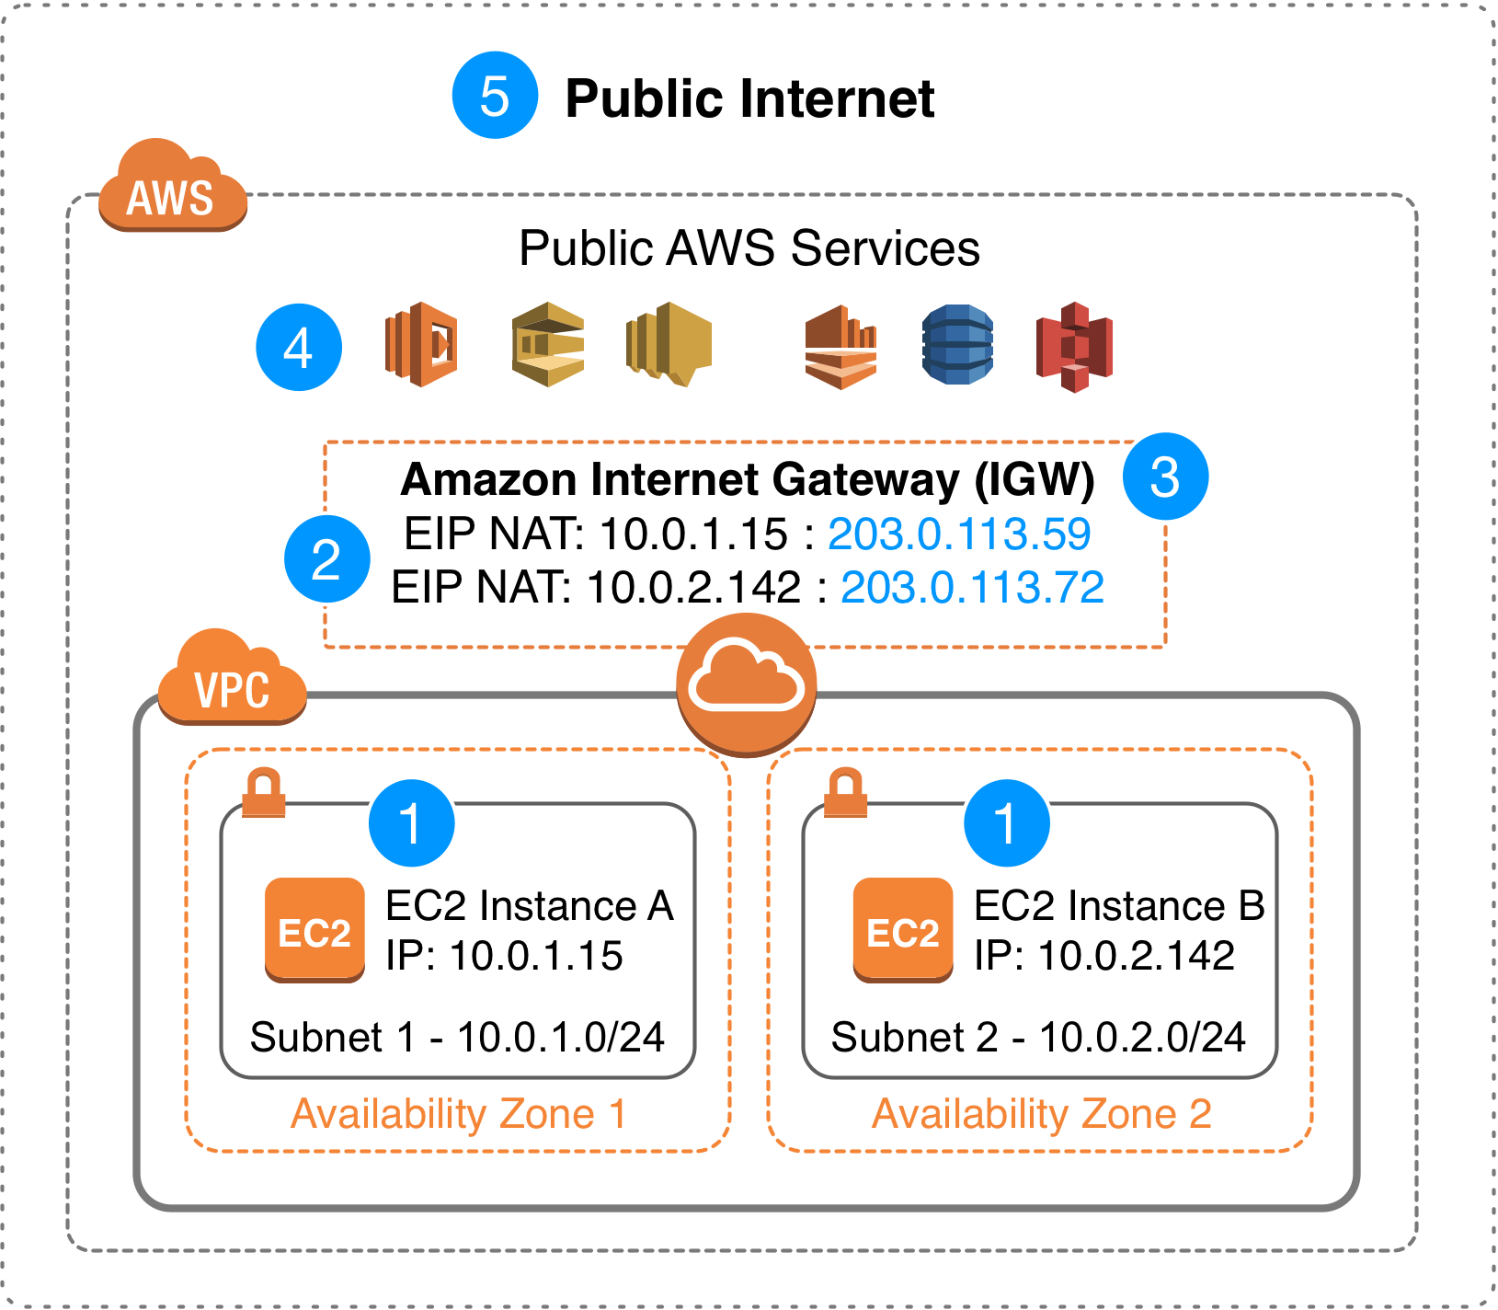
Example
resource "aws_eip" "app" {
instance = aws_instance.app.id
}
Why EIPs matter
- stable public IP
- DNS-friendly
- useful for legacy systems
⚠️ Unattached EIPs cost money.

Quick comparison table
Concept | Purpose
Data Source | Read existing resources
Locals | Store calculated values
depends_on | Force creation order
Dynamic | Generate nested blocks
Authentication | Secure provider access
EIP | Static public IP (AWS)

How they work together (real-world flow)
- Authentication → lets Terraform talk to APIs
- Data sources → fetch existing infra
- Locals → calculate config values
- Dynamic blocks → reduce repetition
- depends_on → ensure correct order
- EIP → assign stable networking

One-sentence takeaway
These features don’t create infrastructure by themselves — they make Terraform smarter, safer, and more maintainable.
This is a really good question — understanding arguments vs attributes is one of those things that suddenly makes Terraform “click”.

The big idea
In Terraform:
- Arguments = what you set
- Attributes = what Terraform gives you back
Inputs vs outputs.

Arguments in Terraform
Arguments are the configuration values you define inside a block.
You are telling Terraform:
“Create this resource like this.”
Example (arguments)
resource "aws_instance" "app" {
ami = "ami-0abcdef123" # argument
instance_type = "t3.micro" # argument
tags = { # argument
Name = "app-server"
}
}
Everything on the left-hand side that you set is an argument.
Arguments can be:
- required
- optional
- computed later (but still configurable)

Attributes in Terraform
Attributes are values that exist after Terraform creates or reads something.
Terraform says:
“Here’s what I now know about this resource.”
Example (attributes)
aws_instance.app.id
aws_instance.app.public_ip
aws_instance.app.private_ip
These values:
- are generated by the provider
- often unknown during plan
- become known after apply

How arguments and attributes connect
resource "aws_eip" "ip" {
instance = aws_instance.app.id
}
- instance → argument
- aws_instance.app.id → attribute
You feed attributes from one resource into arguments of another.
That’s how Terraform builds dependency graphs automatically.

Arguments vs Attributes side-by-side
Feature | Arguments | Attributes
Who sets it | You | Terraform / provider
When known | Plan time | Apply time
Used for | Configuration | References
Example | instance_type | id, arn, ip

Data sources follow the same rule
data "aws_ami" "ubuntu" {
most_recent = true # argument
}
data.aws_ami.ubuntu.id # attribute
Same concept — different block type.

Attributes can be nested
Attributes can be deep and structured:
aws_instance.app.network_interface[0].network_interface_id
Still an attribute — just nested data.

Computed attributes
Some attributes are computed-only:
- you can read them
- you can’t set them
Example:
aws_instance.app.public_dns
You can reference it, but never configure it.

Common beginner mistake 🚫
Trying to set an attribute:
resource "aws_instance" "bad" {
id = "i-123456" # ❌ not allowed
}
id is an attribute, not an argument.

Mental model (easy to remember)
- Arguments go into Terraform
- Attributes come out of Terraform
Or:
You declare arguments, you reference attributes.

One-sentence summary
Arguments configure resources; attributes are the resulting values Terraform exposes after creation or lookup.
In Terraform, lookup is a built-in function used to safely fetch a value from a map.
Think of it as:
“Get me this key from the map — and don’t blow up if it’s missing.”

Basic syntax
lookup(map, key, default)
- map → a map (or object)
- key → the key you want
- default → value returned if the key doesn’t exist

Simple example
variable "tags" {
type = map(string)
default = {
env = "dev"
team = "platform"
}
}

locals {
environment = lookup(var.tags, "env", "unknown")
owner = lookup(var.tags, "owner", "n/a")
}
Results:
- environment → "dev"
- owner → "n/a" (key didn’t exist)

Why lookup exists
Without lookup, this fails if the key is missing:
var.tags["owner"] # ❌ error if "owner" doesn't exist
With lookup:
lookup(var.tags, "owner", "n/a") # ✅ safe

Real-world use cases
Environment-specific values
locals {
instance_type = lookup(
{
dev = "t3.micro"
prod = "t3.large"
},
terraform.workspace,
"t3.micro"
)
}

Optional configuration
timeout = lookup(var.settings, "timeout", 30)

Tags with defaults
tags = merge(
{
Environment = lookup(var.tags, "Environment", "dev")
},
var.tags
)

lookup vs try vs direct indexing
Method | When to use
lookup() | Safe map access with default
try() | Multiple fallbacks
map[key] | When key is guaranteed
Example with try:
try(var.tags.owner, "n/a")

Important notes ⚠️
- lookup works with maps and objects
- The default value must match the value type
- Overusing lookup can hide config errors — use thoughtfully

Common mistake 🚫
lookup(var.tags, "count", 0)
If var.tags is map(string), default must be a string, not a number.

One-sentence summary
lookup safely retrieves a value from a map in Terraform and returns a default if the key doesn’t exist.

